Practical - 3
Practical Title: Responsive UI Design using CSS Grid, Flexbox, and Bootstrap/Tailwind
Problem Definition 1: Design responsive layouts for Home, About, Registration, Dashboard, and Events pages using CSS Grid and Flexbox. Optional to use CSS framework such as Bootstrap or Tailwind. Ensure mobile-first responsiveness.

Theory
1: How does the layout adapt for mobile, tablet, and desktop screens?
Answer: By setting margin to auto.

2: Which layout technique is used and why?
Answer: I used heading then information layout because it is easy to approach and user friendly.

3. Are typography, spacing, colors, and contrast readable?

Answer: Yes I have set background image and text colors such that it has warmth and it does not give strain to the eye.

Implementation/ Output/Result (Keep only one option which is suitable to practical)

CSS Features & Properties Summary
Basic Styling: Use of margin, padding, box-sizing, width, and height to control spacing and element sizes.
Page Layout: Use of display, flex, justify-content, align-items, gap, and margin: auto for arranging and centering elements.
Text Styling: Use of font-family, font-size, font-weight, text-align, line-height, letter-spacing, and text-decoration.
Colors & Backgrounds: Use of background colors, text colors, Hex/RGB/RGBA values, and background images.
Boxes & Cards: Use of border, border-radius, box-shadow, padding, and background properties to create styled sections and cards.
Tables: Use of border-collapse, borders, padding, and alignment to format tables.
User Interaction: Use of :hover and :focus, along with transition, transform: scale(), and cursor: pointer for interactive effects.
Positioning: Use of position, relative, absolute, and z-index to control the placement of elements.
Responsive Design: Use of @media (max-width: 768px) to make layouts, tables, fonts, and widths suitable for smaller screens.

- Evidence of Work (Screenshots):
CSS SCREENSHOTS:

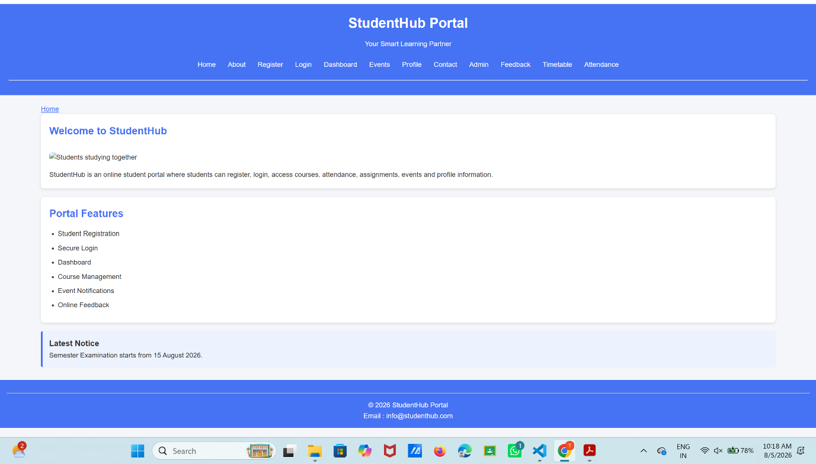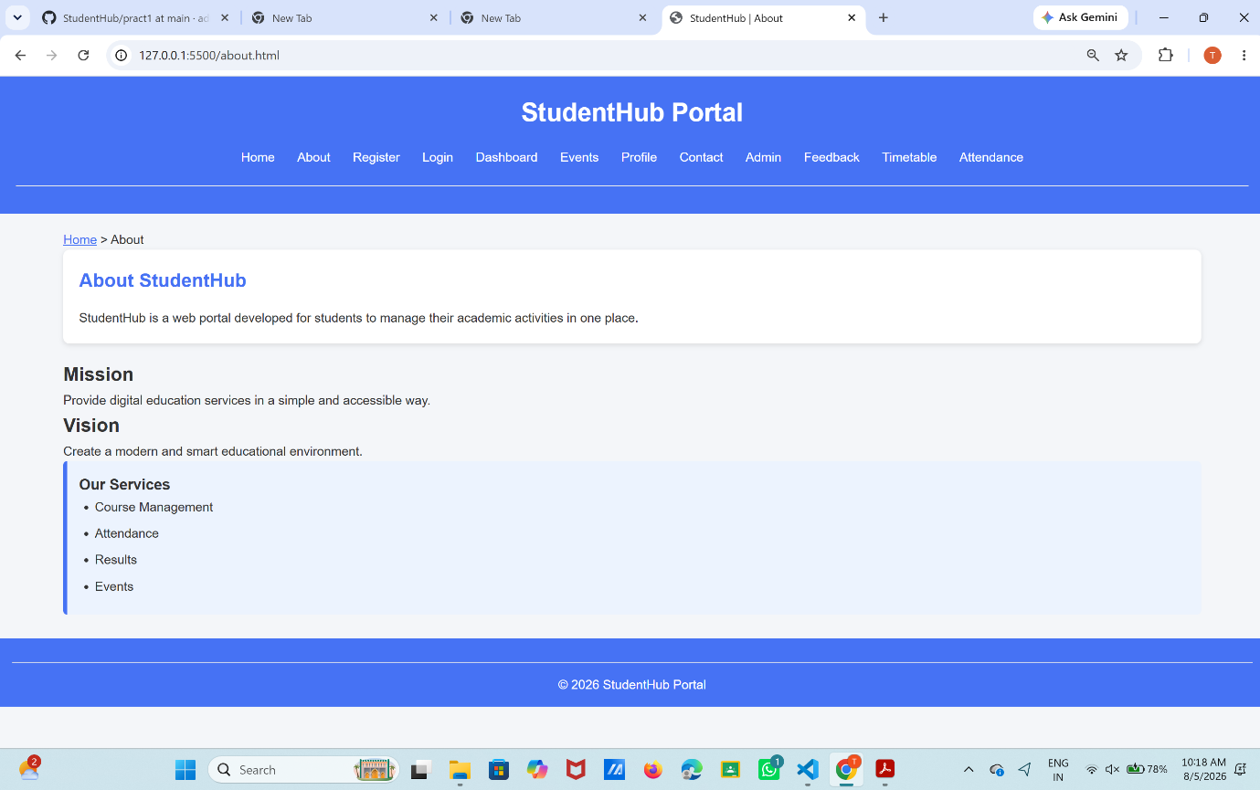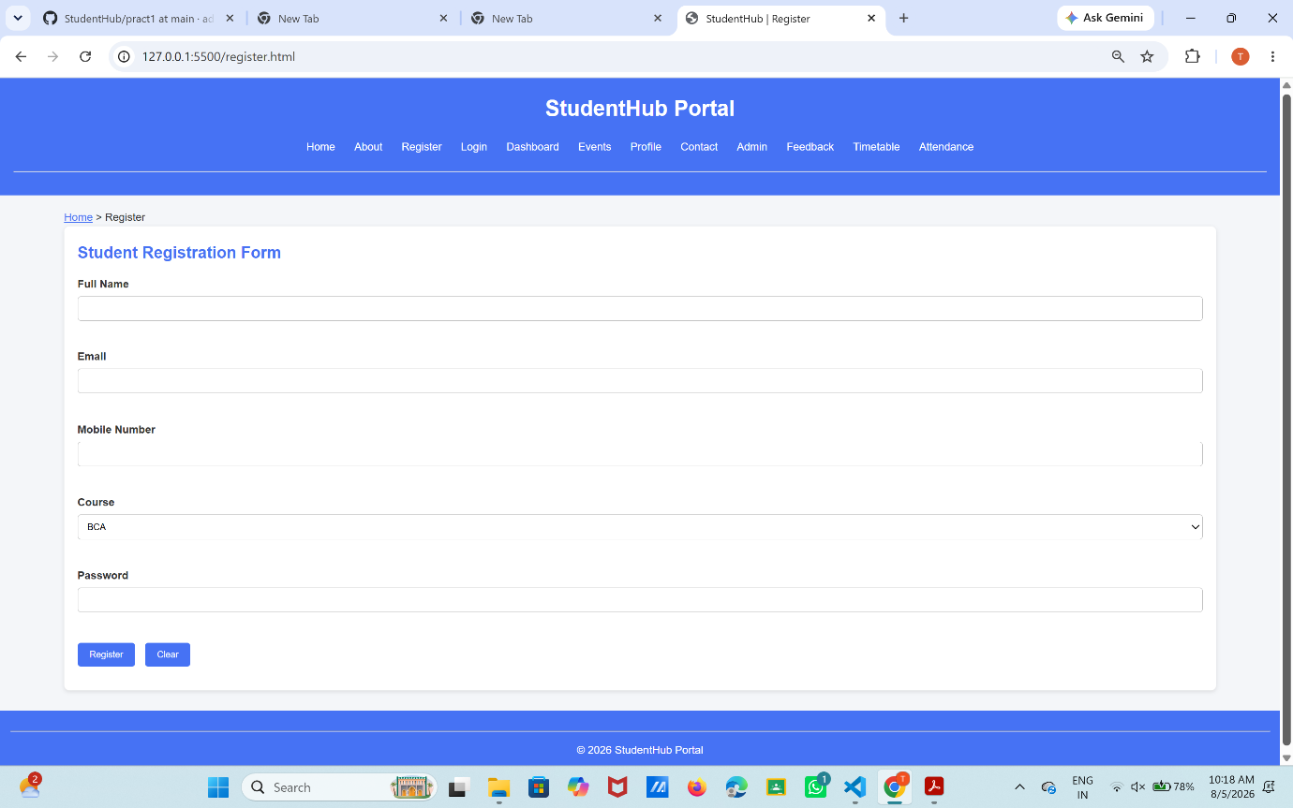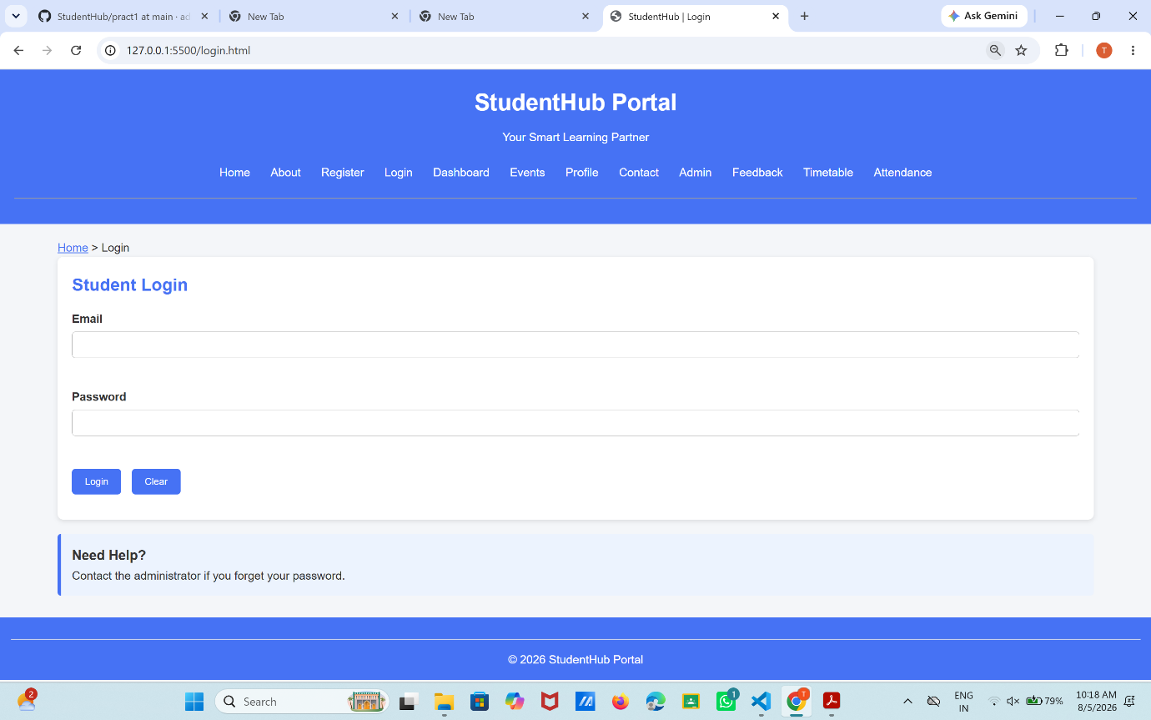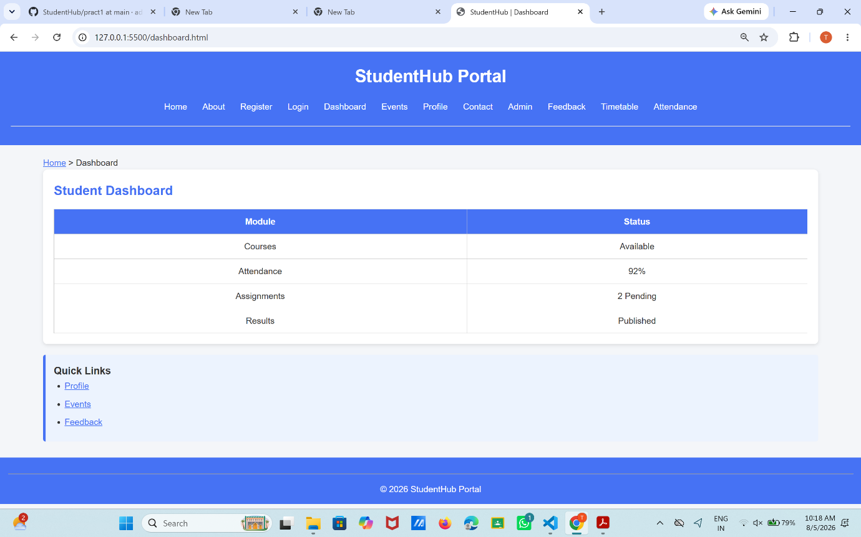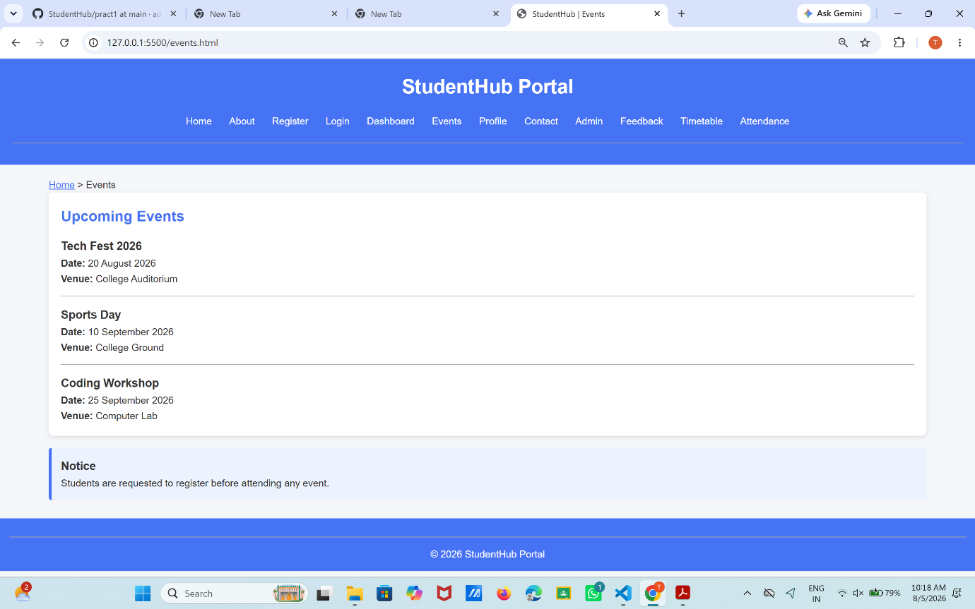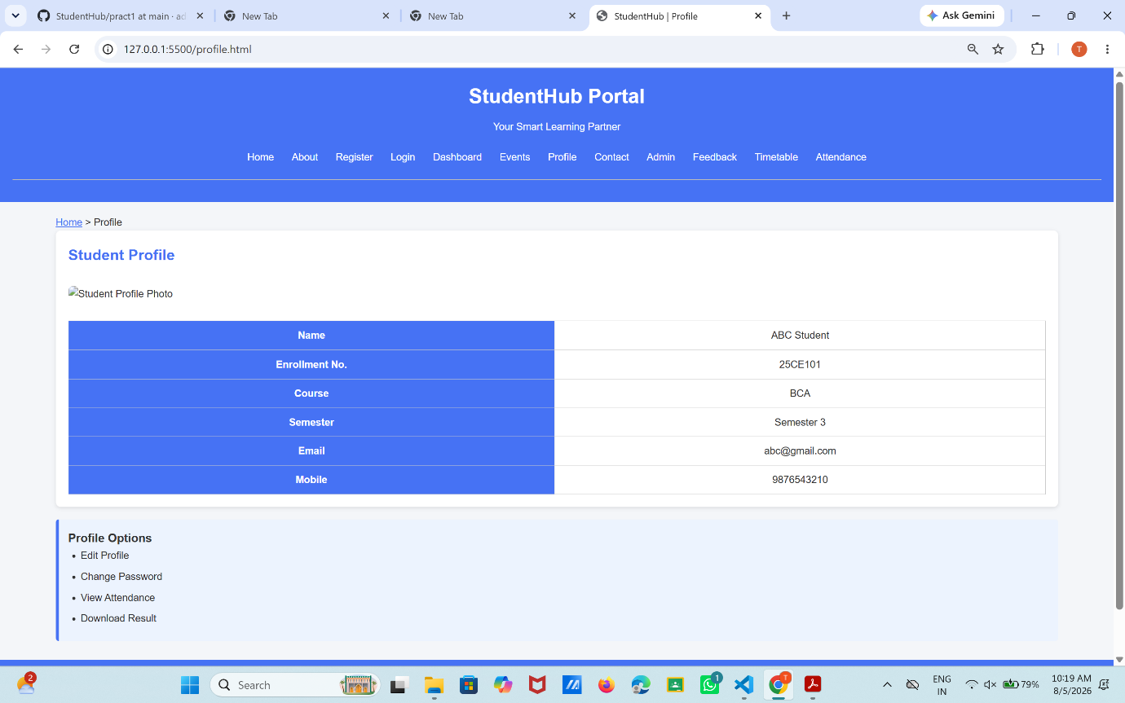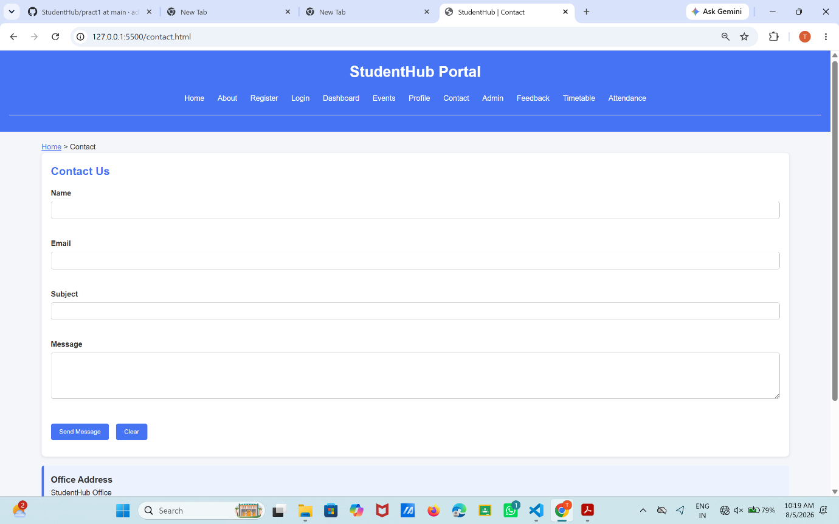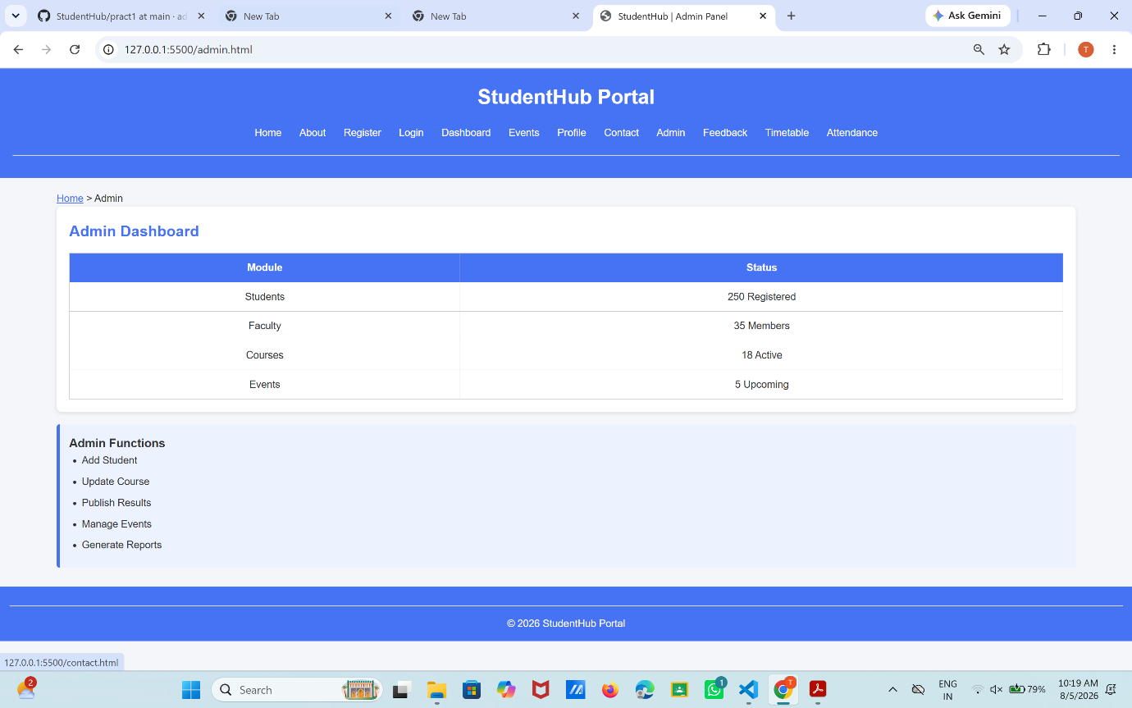

GitHub Repository Link:
https://github.com/adrojatarang8-art/StudentHub.git

Challenges Faced:
GITHUB REPO. CREATION,FOLDER CREATION,FILE CREATION.
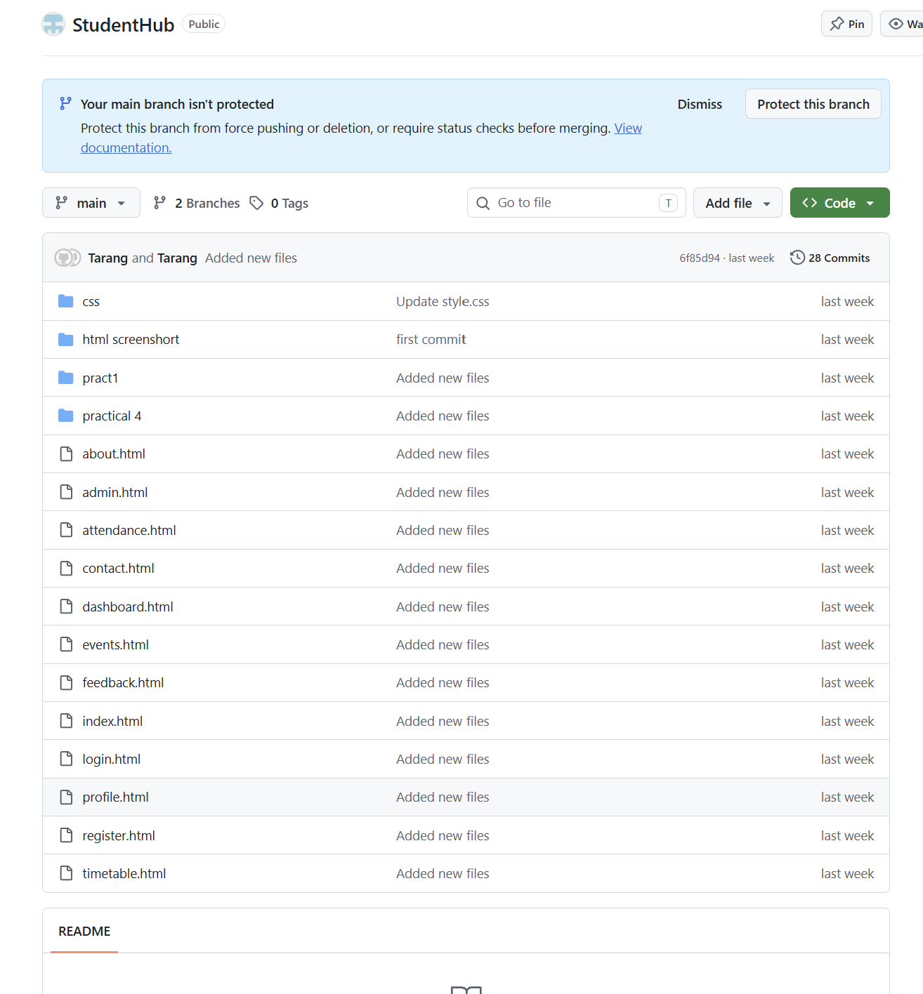
VSCODE FOLDER,FILE CREATION.
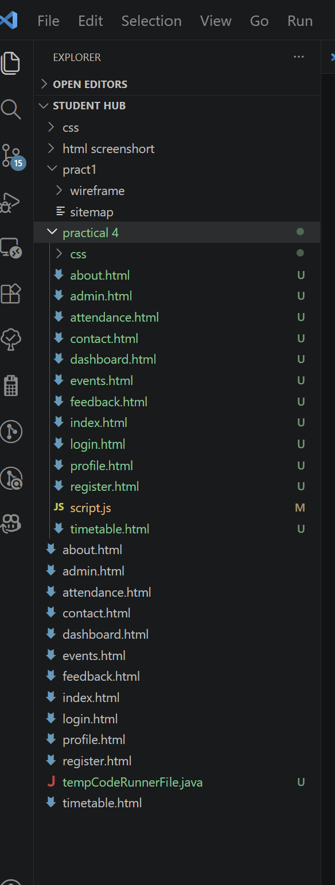
Background image setting:
It was hard to make the background image set on the website like that how it can be seen in the screenshots but with the help of autopilot and google and appropriate tags and style options in CSS I was able to nail it.

Learning Outcomes:

I LEARNED WEBSITE CREATION, SITEMAP, WIREFRAME, GITHUB, REQUIREMENT ANALYSIS, HTML, FILE MANAGEMENT

Faculty Remarks: (Keep this blank for faculty)

